# Lab 4 Prelab: ON/OFF Button

(2 hours)

## Goal

To learn how to implement an ON/OFF Button.

## Procedure

Implement the ON/OFF Button learnt in class with the following function diagram (see slides of lecture 4).

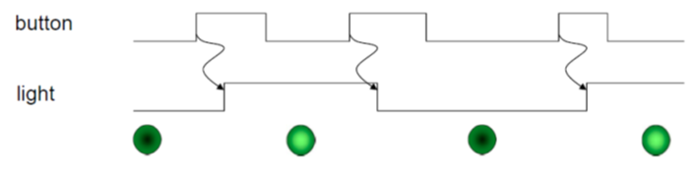

1. Test whether the following code can have the correct results.

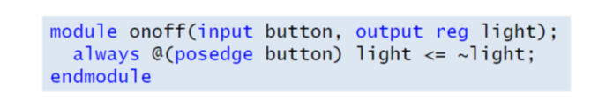

1. Write the correct Verilog module and implement it in the board.



1. There are three processing sub-circuits in the module. Try remove part of them and test wither the results are correct.